**Time- 3 H SCIENCE-IX ( SA-II ) M.M-90**

**General Instructions:**

(i)The question paper comprises of two sections ,A and B .You are to attempt both the sections.

(ii)All questions are compulsory.

(iii)There is no overall choice.

(iv)All questions of section A and all questions of section B are to be attempted separately.

(v)Question numbers 1 to 3 in section A are one mark questions .These are to be answered in

one word or in one sentence.

(vi)Question numbers 4 to 6 in section A are two marks questions.These are to be answered in

about 30 words each.

(vii)Question numbers 7 to 18 in section are three marks questions .These are to be answered in

about 50 words each.

(viii)Question numbers 19 to 24 in section A are five marks question.These are to be answered in

about 70 words each.

(ix)Section B are multiple choice questions based on practical skills.Question numbers 25 to 33 are

one mark questions .Question numbers 34 to 36 are two marks question .You are to select one

most appropriate response out the four provided to you

***SECTION-A***

Q1.Relative of steel is 7.8 .what is its density?

Q2.Mention any one effect of increase in the amount of greenhouse gases in the atmosphere.

Q3.In which kingdom would you place an organism which is single celled, eukaryotic and

photosynthetic?

Q4.When is work said to be done against the force of gravity? State and define SI unit of work.

Q5.How are the electrons distributed in the various shells of the atoms of the elements: argon (atomic

number 18),(atomic number 11),fluorine (atomic number 9) and sulphur (atomic number 16)

Q6.List two distinguishing features between Annelid animals and Arthropods.

Q7.What is meant by buoyancy? Why does object float or sink when placed on the surfaces of a liquid?

Q8.The kinetic energy of an object moving with a velocity of 5 m/s is 25 J.Find the mass of the object

.what will be its kinetic energy when its velocity is made

(i)two times (ii)three times?

Q9.Define commercial unit of energy .Derive relationship between this unit of energy and SI unit of

energy and SI unit of energy .An electrical device of 500 W is used daily in a household for 10 hours.

Calculate the energy consumed in the month of April.

Q10.What is SONAR? For what it is used? Explain in brief working.

Q11.Distinguish between longitudinal and transverse waves .Give one example of each.

Q12 Write the meaning of formula unit mass .How is determined? Calculate the formula unit mass of a

compound Na 2 S2O3. (Given, atomic mass of Na =23 u,S=32u,O=16u.)

Q13.List three conclusions drawn by Rutherford from his a–particle scattering experiment .State three

features of nuclear model of an atom put forward by Rutherford.

Q14.(i)State the limitations of *J.J.*Thomson’s model of an atom.

(ii)Define valency by taking the examples of magnesium (At .No=12) and oxygen (At. No=8)

(iii)S2- has completely filled K, L and M sheels.Find its atomic number.

Q15.Explain why is there a change in the wind direction in coastal areas during the day and at night.

Q16.Health workers are exposed to more sick people than others in the community .Write any four

preventive measures they take to avoid sickness.

Q17.Anil and Sunil were on a trip to Taj Mahal in Agra .They were watching closely the tombs .Anil said

to Sunil, “Do you remember we came to see the Taj four years back?It was whiter as compared to

today .Now the whiteness of the marble has gone down” .”Yes, I also feel the same “, said Sunil to

his brother Anil,”But what can be the reason?”

(i)Can you explain why the attractiveness of the Taj is showing a decrease with time?

(ii)What is the rain containing the pollutants called?

Q18.Same drug does not work against the microbes belonging to different groups .Why? State the

mechanism of antibiotics in killing bacteria.

Q19.What is meant by power of a machine? Name and define its SI.unit .How is kilowatt different from

kilowatt hour?

From a 20 m high fall nearly 25 metric tonnes of water fall per second .Calculate the equivalent

power if all this energy is utilized .(g=10 m/s2)q

20. Define the following terms and state their SI units:

(i)Wavelength (ii)Time period (iii)Amplitude

Establish the relation v=v  where symbols have their usual meanings.

Q20.Define the following terms and state theirs units:

(i)Wavelength (ii)Time period (iii)Amplitude

Establish the relation v=v where symbols have their usual meanings.

Q21.(a)Chlorophyll ,the green coloring matter of plants ,responsible for photosynthesis contains 2.64%

of magnesium by mass .Calculate the number of magnesium atoms in 2.00 g of chlorophy11.

(b)When methane is analysed, it is found to contain 75% carbon and 25% hydrogen. Calculate the

simplest formula of methane.

Q22.Describe the various pollutants in the atmosphere.

Q23.State the type of cells Monerans have .Explain their structure and the types of nutrition they have.

Q24.(a)List two distinguishing features between Poriferan and Coelenterate animals.

(b)Give reasons to justify the following statements:

(i)Crocodiles have four chambered heart but are still reptiles.

(ii)Forelimbs of

(iii)Forelimbs of birds are modified.

***SECTION-B***

Q25.A reaction between barium chloride and sodium sulphate was carried out in a sealed conical flask

.The masses of the reactants and the products were measured carefully .After the experiment it was

concluded that

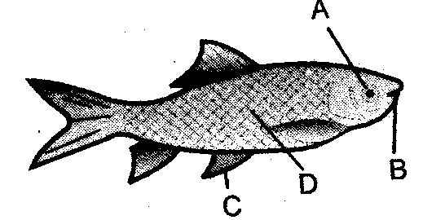

(a)Mass of barium chloride=Mass of sodium chloride

(b)Mass of sodium sulphate =Mass of barium sulphate

(c)Mass of (barium sulpahte+sodium chloride)

(d)Mass of (barium sulphate +sodium chloride)=Mass of (barium sulpahte+sodium sulphate)

Q26.An animal covered by chitin covering having wing, antennal and jointed legs is

(a)Cockroach. (b)Flat worm (c) Leech (d)Nereis

27. Chloroplast present in spirogyra are

(a)book shaped (b) irregular in shape (c) ribbon shaped (d) spiral shaped.

Q28.The correct labeling of parts A, B, C, and D is

(a)A-Mouth,B-Eye,C-Fin,D-Scale (b)A-Eye,B-Mouth,C-Fin,D-Scale

(c)A-Mouth,B-Scale,C-Eye ,D-Fin (D)A-Fin,B-Eye,C-Scale,D-Mouth

Q29.A student using spring balance records the weight of iron cube in air, in tap water and in

concentrated solution of common salt in water .If his three readings taken in this order are W1,W2,

and W3 ,he is likely to observe that

(a)W1>W2>W3 (b)W1>W2=W3 (c)W1>W3>W2  (d)W1=W2<W3

31. Four measuring cylinders with different least counts are shown in Fig.A, B, C and D.

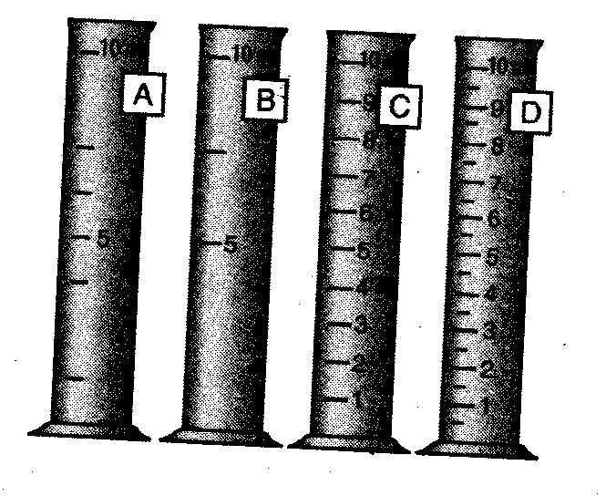

The most suitable for determining the volume of a cube of side nearly 1 cm is

(a)A (b)B (c)C (d)D

Q32.Along which of the following four directions OA,OB,OC and OD a narrow tube be placed so that the

ticking of a clock placed at P is heard the loudest after being reflected from the reflecting surface.

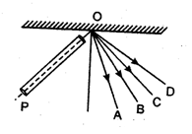

(a)OA (b)OB (c)OC (d)OD

Q33.While doing the experiment on measuring the velocity of a pulse through a stretched string a

student had to choose from the following:

(A)Thick silk string (B) Thick woolen string (C) Stop watch (D) Table clock

(E)8 m long thick cotton string (F)2 m long thin cotton string

For test result the proper choice of the combination is :

(a)A, C, E (b) C, E (c) B, D, F (d) B, D

34. Four students A, B, C and D observed the seeds and flowers of pea plant .They reported that the

seeds and flowers of pea plant are:

(a)monocotyledonous seeds and pentamerous flowers.

(b) monocotyledonous seeds and trimerous flowers.

(c)dicotyledonous seeds and pentamerous flowers.

(d)dicoyledonous seeds and trimerous flowers.

Q35.A metallic cuboid of mass 7.5 kg and dimensions 5 cmX 10 cm X 20 cm is placed on a table to exert

pressure on its surface .If g=10 m/s2 the maximum pressure which can be achived by the cuboid is

Q36.A longitudinal pulse was created in a slinky of length 6m by a group of four students A,B,C and D

.They observed that the pulse completed its four to and fro journeys in 10 s.On the basic of this data

the speed of pulse in the slinky is

(a)4.8 m/s (b)6.4 m/s (c)7.2 m/s (d)9.6 m/s